## What is space in interior design?

Space, in interior design, refers to the physical area within a room or building that can be occupied, used, and experienced by people. Space is one of the fundamental elements of design and is the foundation upon which all other design elements are applied. Space is typically divided into two types:

* **Positive Space:** This is the area occupied by objects, furniture, or accessories or decor.
* **Negative Space:** Also known as "white space” or “blank space," this is the empty or open area around and between objects. Negative space will balance a room and ensure it doesn’t feel cluttered or overcrowded.

Because space often relates to a three-dimensional feature, it can also be evaluated in terms of volume, as well as contrast between positives and negatives. The importance of creating negative space within any design cannot be overstated. Interior designers can use negative space to highlight certain design elements, emphasise the furniture, and/or maximise the functionality of each room.

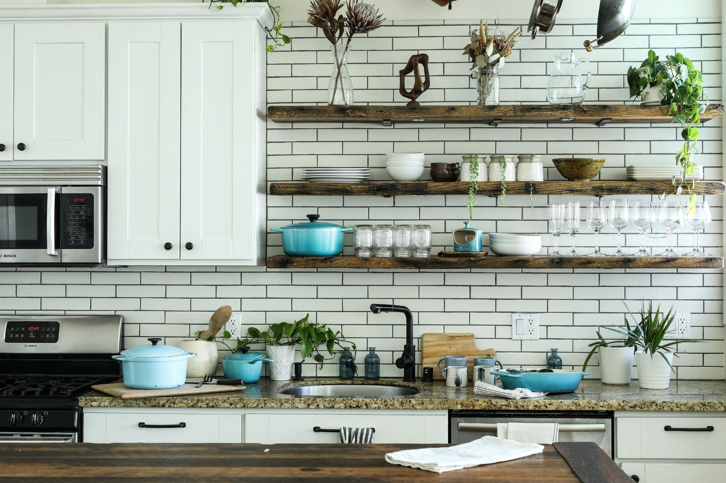

Fig. 1. Unsplash (n.d.), Utilisation of negative space for decorative purposes through open shelving

Understanding negative space means you can design even the smallest of spaces, to their full potential. Too little negative space and a room can feel cluttered. Too much negative space, and the room will feel under-furnished. Balance is therefore key.

## Why is space important in interior design?

### When designing anything from a residential room to a large-scale commercial or public area, space is arguably one of the most important elements that an interior designer must consider. Effective spatial design allows you to use a room to its maximum potential and can enhance functionality, flow, and movement. Space can also be utilised to create balance and proportion, aesthetic appeal and to promote comfort and wellbeing.

#### Functionality

The way an interior space is organised and used directly impacts the functionality of a room. Proper spatial planning ensures that the space meets the needs of its users, whether it’s for living, working, or recreation. For example, in a kitchen, enough space must be allocated for cooking, movement, and storage, making the space practical and easy to use.

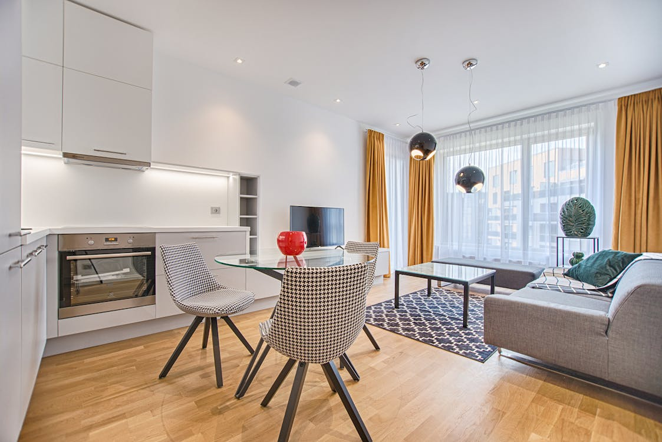

Fig. 2. Pexels (n.d.), Open Plan Layout

#### Flow and Movement

Space determines how people move through a room or building. A well-designed space allows for smooth circulation, making it easy to navigate from one area to another without obstruction. As an interior designer, you must always consider traffic flow in, out and around a room – especially in a busy space such as a kitchen or retail outlet. It would help if you ensured there is enough space in and around objects and that busy thoroughfares are kept free of furniture.

In an open floor plan, space must be thoughtfully arranged to define different zones while maintaining a cohesive flow throughout the area.

#### Balance and Proportion

Space helps achieve visual balance in a room by ensuring that furniture and decor are appropriately sized and placed. Overcrowding a room with too many items can make it feel cramped, while too much empty space can make it feel sparse and uninviting. In interior design, three distinct and separate applications of balance may exist using space:

* Symmetrical balance
* Asymmetrical balance
* Radial balance

More often than not, these are created by the physical elements in a room (i.e. the furnishings and architectural details), but can also be created using colour, texture and/or scale.

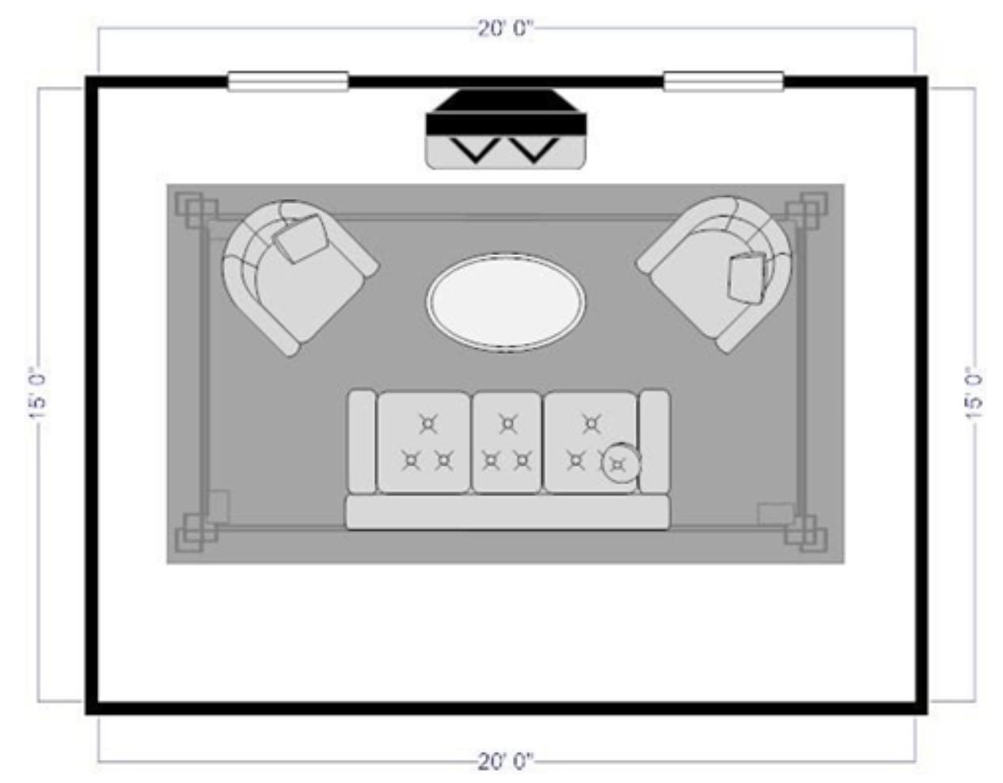

Fig. 3. Layout within the space arranged to create symmetrical balance

Proportion involves the relationship between different elements within a space, ensuring that all parts of the design work harmoniously together.

#### Aesthetic Appeal

Besides function, the use of space can also contribute significantly to the aesthetic quality of a room. For example, the creation of both balance and the effective use of negative space, can enhance the overall look of a room. It can make a space feel more open, airy, and visually pleasing. Designers often use space to create focal points, such as a statement piece of furniture or an artwork, by giving it room to stand out. These are just a few examples of how space can be used to visually appeal to its users.

#### Comfort and Well-being

The way space is designed can greatly affect the comfort and well-being of the occupants. A well-spaced room can promote relaxation and reduce stress, while a poorly organised space can lead to discomfort and frustration. The amount of negative space can also influence the perception of the room’s size, making it feel either more expansive or more confined, which in turn affects how comfortable people feel in the space.

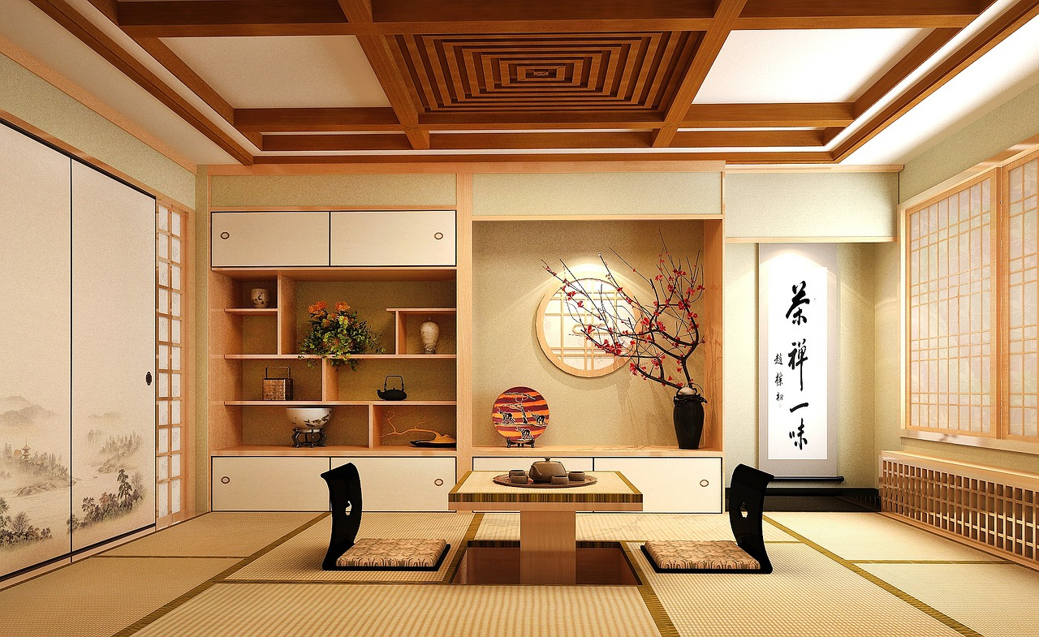

Fig. 4. Pixabay (n.d.), Japanese design is known for celebrating minimalism and using space to enhance wellbeing

#### Flexibility and Versatility

Thoughtful space planning allows for flexibility in how a room can be used. For instance, a living room with adequate space can easily be rearranged for different activities, from entertaining guests to family movie nights. In your role as an interior designer, you may be required to create multifunctional spaces that can adapt to the changing needs of the users. You will therefore need to be creative with space, especially with small rooms, and be able to design it in a way that allows for dual functionality. For instance, designing a guest room that doubles as a home office.